Bridge between research in modern physics
and entrepreneurship in nanotechnology

Quantum Physics
The physics of the very small
with great applications

Part 2
QUANTUM PROPERTIES & TECHNOLOGY
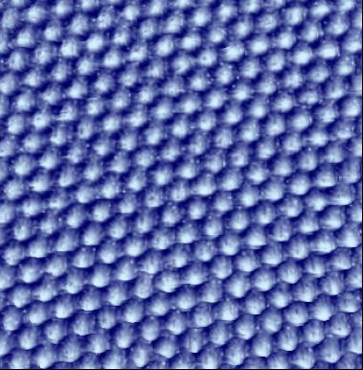

Learning Station VIII:
A: Tunnelling

Quantum Spin-Off is funded by the European Union under the LLP Comenius programme
(540059-LLP-1-2013-1-BE-COMENIUS-CMP).
Renaat Frans, Robert Sum
Contact:
renaat.frans@khlim.be
sum@nanosurf.com
Table of Contents

Learning station IX: Tunnelling & STM 102
1 Over a potential barrier without the needed energy 102
1.a Classical particles cannot tunnel 102
1.b Light can tunnel through a barrier 102
1.c Tunnelling in daily life 104
2 Tunnelling: a characteristic of waves 104
3 Electrons can tunnel too 105
3.a An application: Flash Memory 106
3.b Flash Memory explained by tunnelling of electron waves 106
3.c Tunnelling underlies many processes 107

Attribution-NonCommercial-ShareAlike 4.0 International (CC BY-NC-SA 4.0)
Under the following terms:
- Attribution — You must give appropriate credit, provide a link to the license, and indicate if changes were made. You may do so in any reasonable manner, but not in any way that suggests the licensor endorses you or your use.
- NonCommercial — You may not use the material for commercial purposes.
You can:
- Share — copy and redistribute the material in any medium or format
- Adapt — remix, transform, and build upon the material
The licensor cannot revoke these freedoms as long as you follow the license terms.
You have to refer to this work as follows:
Frans R., Sum R. (2014) Quantum SpinOff Learning Stations: Tunnelling & STM. Centre for Subject Matter Teaching KHLim, Diepenbeek Belgium - Nanosurf AG, Liestal

Learning station VIII:
Tunnelling & STM

Over a potential barrier without the needed energy

Classical particles cannot tunnel
(Source: Concord.org)

If you want a ball to roll over a hill top, you need to give it enough (kinetic) energy to overcome the barrier of potential energy which is formed by the hill.
- If it does not have enough energy, it (will/will not) pass the top
- If it does have enough energy, it (will/will not) pass the top
The strange thing is that unlike macroscopic balls, quantum particles, like electrons and photons (particles of light) may indeed pass a barrier, even though they might not have the needed energy. In fact quantum physics predict a chance for quantum object to tunnel through an energy barrier depending on the particle’s energy and the height and width of the barrier.

Light can tunnel through a barrier
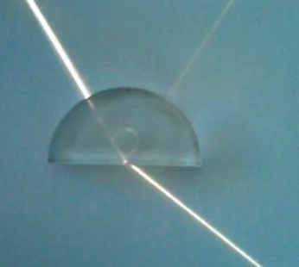
As you remember, light rays that go from an optically dense medium to an optically thin one can be totally reflected or transmitted. The effect is due to the changing velocity of light which is (slower/faster) in the dense medium than it is in the thin.
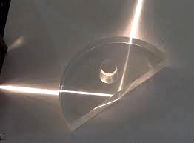
If the angle of incidence is larger than a certain critical angle, which depends on the relative refractive index, the light is totally reflected in the optically dense medium.
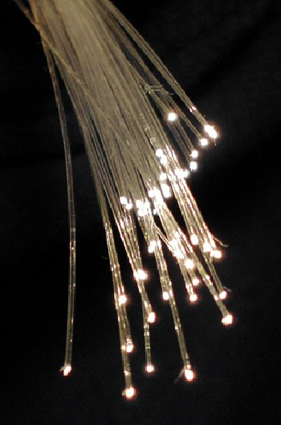

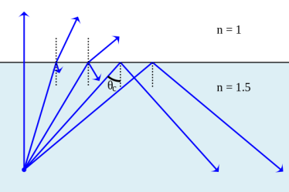
(Source: Wikipedia public domain)
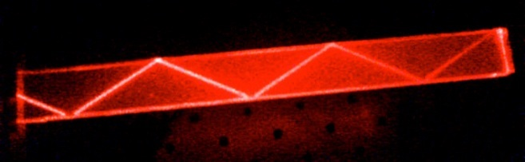
This makes it possible for light to stay in an optical fibre. Thus light cannot come out of the dense medium once the angle of incidence is large enough.
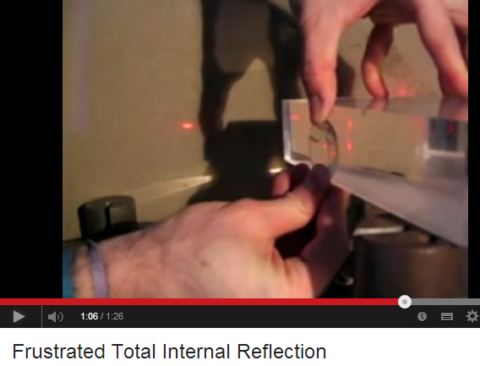
But the effect of tunnelling makes it now possible for light to overcome this not to exceed barrier. We can show this in an experiment with two prisms. You can watch this experiment on http://www.youtube.com/watch?v=aC-4iSD2aRA

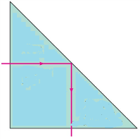
Experiment: frustrated total internal reflection with light
As an example let us consider shining a laser beam on one side of a prism as on the figure. On the other side the angle of incidence is large enough to get total internal reflection: the light cannot leave the medium.
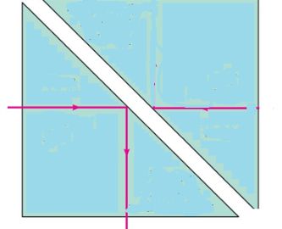
But then we approach with a second prism. When we press the second prism to the first (if necessary you can wet the sides with water) at once the light can leave the first prism and make it to the second prism although it is classically forbidden to overcome this gap.
A classical particle cannot know that you are holding a second prism nearby. It is because of the quantum wave character of light that it can penetrate the gap and has a chance to tunnel through the gap.

Experiment: frustrated total internal reflection with microwave
The gap between the prisms should be of the order of the wavelength of the light. For red light this is about 600 nm. This means the two prisms should be very close to each other. For microwaves, who have wavelengths in the order of centimeters, it can be shown that a gap of a few centimeters is is already enough to get tunneling.
You can look at an experimental implementation with microwave tunnelling at http://www.sixtysymbols.com/videos/reflection.htm
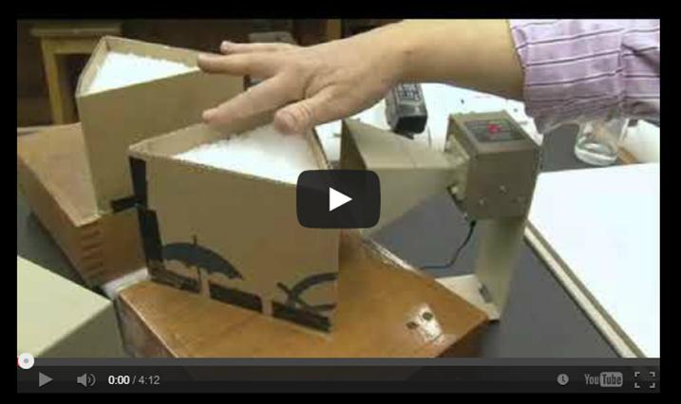
(Source: University of Nottingham)

Tunnelling in daily life
When a glass of water is held, you can’t see your fingers due to total internal reflection of the light in the water.
But when you press your fingers firmly to the glass, the ridges in your skin are becoming visible because the light tunnels through the gap. Light tunnels from the glass into the ridges through the very short (air) gap that forms when you press (Source Wikpedia public domain)

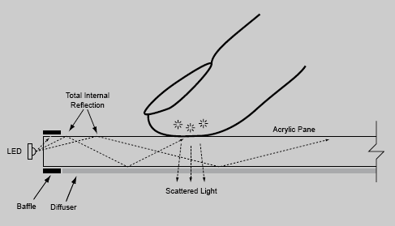
This tunnelling effect with light (breaking total internal reflection), can be used to make a touch screen: one can detect by means of a light sensitive cell, the reflected light and detect where your finger is on the screen.
(Source: New York University: cs.nyu.edu/~jhan/ftirsense/ )

Tunnelling: a characteristic of waves
Let us explain this phenomenon of tunnelling.
Frustrated total internal reflection: Explanation by tunnelling
As long as the light is totally in the glass it cannot ‘know’ what is beyond the glass. To find out it has to penetrate a short distance into the forbidden zone, perhaps a few wavelengths. If a second piece of glass is placed within the penetration distance, the beam can reappear. The probability to penetrate the air gap decreases as the thickness of the barrier increases.
Tunnelling of water waves
The total internal reflection is caused by a sudden change in the propagation velocity of light at the boundary. For example in glass the speed of light is much (slower/faster) then in air.
The speed of water waves is also dependent on the depth of the water. In shallow water the velocity of the waves is slower whereas in deep water the water waves propagate faster. Therefore with water waves you can also see the phenomenon of total internal reflection as it is seen with light in matter.

The two slope lines mark a zone where the water is deeper. The waves which are coming from the left, are reflected on this deep zone.

When the gap created by the deep water is made sufficiently narrow (of the order of magnitude of the waves themselves) suddenly the waves can tunnel through the gap and are (partially) transmitted across.

Source Education Development Center,
Newton, MA USA

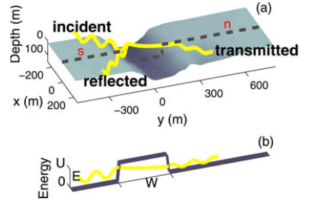
.
The tunnelling of waves is also observed with ocean waves above sea bottom canyons!

Thomson, J., Elgar, S., & Herbers, T. H. C. (2005). Reflection and tunneling of ocean waves observed at a submarine canyon. Geophysical research letters, 32(10).

Electrons may tunnel too
Since we know that light and matter both have this particle-wave duality, tunnelling is not only possible for photons but it is possible for electrons too.
Precisely quantum physics describes this wave character of electrons. Electron waves can tunnel through a classically impenetrable barrier.
So for quantum physics it is natural that also electrons can tunnel through a barrier although they do not have enough energy to overcome that barrier.

An application: Flash Memory
A nice application based on electron tunnelling is flash memory that is used in usb sticks, on smart cards and the like. It will maintain its data without any external source of power.
It is based on electron storage. Electrons are stored in a so called Floating Gate that is isolated from the rest of the device by insulating oxide layers: any electrons placed on it get trapped there and thus store the information.
The electrons are tunnelled through the insulating layer and trapped in the Floating Gate. After the tunnelling the barrier should be made thick enough to keep them there for many years.
The tunnelling of electrons through a (electric) potential barrier can be understood by the the wave character of the electron, an assumption that is made in quantum physics.

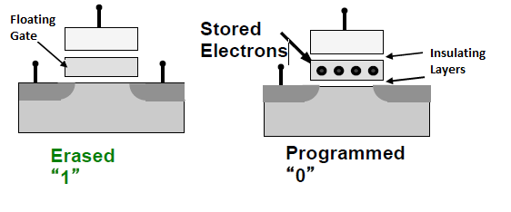
Source: Massachusetts Institute of Technology Open Course Ware

Flash Memory explained by tunnelling of electron waves
The surrounding insulating layers confine the electron in the energy well where it can stay for many years without external power source. This is the basis for the non-volatile storage.
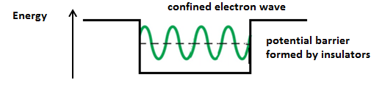
By applying an electric field over the gate, the potential barriers can be made more thin, so the electron can tunnel out of the gate or into it again. Tunnelling makes it possible to write zeros or ones into the gate.

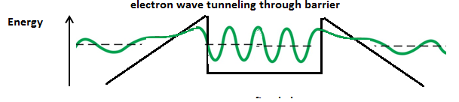
You can find more learning materials on tunnelling and a simulation of the working of the flash memory on concord.org
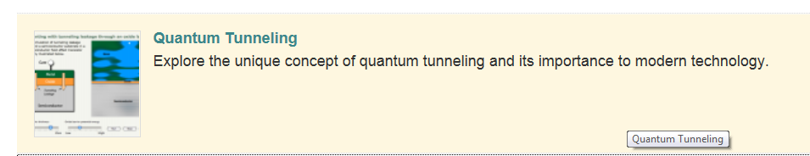
Simulations of Quantum Tunnelling on Concord.org

Tunnelling underlies many processes
It becomes more and more clear that quantum tunnelling plays an important role in chemistry, and also in the chemistry of life. In the photosynthetic process for instance electrons tunnel from one molecule to another, penetrate membranes and the like and therefore make fast energy transfer processes possible. Research in this area has opened up many possibilities in the emerging field of quantum biology, and this may even shed light on a method towards developing more efficient solar cells.
Also processes like the emission of He-particles in radioactive αlpha-decay, can only be understood in terms of tunnelling, in this case out of the atomic nucleus. The pure stochastic nature of radioactive processes are of course to be understood as a consequence of the quantum character of particles. The probabilistic character of nature, which can be seen at nano level, is explained by the wave-particle duality. The amplitudes of the quantum mechanical waves are proportional to the probability of measuring a quantum of energy (a particle) at different places.
In electronic circuits, conductive areas ( formed by metals) in which electrons move are separated by insulating layers in which electrons are classically prohibited. These insulating areas act as barriers to free electrons so that they can move only within the conductive areas. In early circuits, the barriers were very thick, making electron tunnelling negligible. However, when the barriers get thinner, tunnelling becomes significant and the barriers lose part of their confining function. This is a problem for further miniaturisation of circuits. On the other hand, tunnelling gives new opportunities for new applications
In fact, trillions of tunnelling events occur while you are reading this page both in nature as well as in technology. Tunnelling is a new property of nature that nano scientists and engineers need to understand further.
A fascinating application of electron tunnelling is the development of the Scanning Tunnelling Microscope: a device that made it possible to peek into the atomic, even subatomic scale.

See for instance: Moser, C. C., Keske, J. M., Warncke, K., Farid, R. S., & Dutton, P. L. (1992). Nature of biological electron transfer. Nature, 355(6363), 796-802.

