Learning station III: What oscillates with light? 27

1 Mechanical waves 27

1.a Source of mechanical waves 27

1.b Medium needed? 27

1.c Propagation and displacement in the same direction or in a different direction? 28

1.d Do the particles travel along with the wave? 29

1.e The source of light waves 30

2 Intermezzo Sound: Are there vibrations that *don’t* repeat? 30

3 Light: what’s shaking? 33

3.a Force(fields) that can travel through empty space 33

3.b Fields that change in time: waves of a field 35

3.c Electromagnetic waves 36

4 A sea of electromagnetic waves 38

http://i.creativecommons.org/l/by-nc-sa/3.0/88x31.png**Attribution-NonCommercial-ShareAlike 4.0 International** (CC BY-NC-SA 4.0)

Under the following terms:

* Attribution — You must give [appropriate credit](https://creativecommons.org/licenses/by-nc-sa/4.0/), provide a link to the license, and [indicate if changes were made](https://creativecommons.org/licenses/by-nc-sa/4.0/). You may do so in any reasonable manner, but not in any way that suggests the licensor endorses you or your use.
* NonCommercial — You may not use the material for [commercial purposes](https://creativecommons.org/licenses/by-nc-sa/4.0/).

You can:

* Share — copy and redistribute the material in any medium or format
* Adapt — remix, transform, and build upon the material

The licensor cannot revoke these freedoms as long as you follow the license terms.

You have to refer to this work as follows:

Frans R., Tamassia L. (2014) Quantum SpinOff Learning Stations. Centre for Subject Matter Teaching, KHLim Katholieke Hogeschool Limburg, Diepenbeek, Belgium

# Learning station III: What oscillates with light?

Light is a wave, you should be convinced by now. But a **wave of what?** We hope to discover the true nature of light waves: what kind of wave is light?

First we look at mechanical waves like we see on a rope, in water or we hear as sound waves. Then we’ll examine the properties of such waves and determine if they can hold true for light as well.

## Mechanical waves

### Source of mechanical waves

To start with, think of a wave on a rope. How can you get a wave on a rope? What is the origin of the wave?

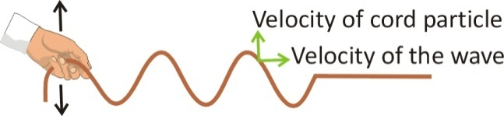  
When you look at a small section of rope, how does it move as the wave travels along the rope?

It is indeed the original vibration that propagates, but the rope itself doesn’t propagate...

Likewise every sound originates in a vibration at its source. For example, what vibrates when you hear the sound of

a guitar?

a piano?

a motor?

But the air particles don’t propagate. It is the vibration of the **sound** that propagates,creating a sound *wave*. Let’s examine this further.

### Medium needed?

The **vibration** could **propagate** through the rope, because the molecules in the rope are connected.

Do you always need a medium through

which the wave can propagate?

Does sound need a medium?

If you were to vibrate a guitar string in a vacuum, would you hear anything?

*Yes/No* Why or why not?

A sound wave can only propagate when the vibrations in the air are passed further from one molecule to the next. Indeed, sound waves do need a medium to propagate.

Mechanical waves need a medium

Does light need a medium?

But **light** can travel through a **vacuum**, or not?

Think of the space between the **sun** and the **earth** or the **stars**: there is no air and virtually no matter: it is empty. Yet we can still see light from the sun and stars! Apparently light can travel *through empty space*. But if so, what kind of wave is light?

Think of the many forms of **wireless** **communication** we use on a daily basis, such as Wi-Fi or the signals of our cell phone or gps networks. They carry information from one place to another through waves. Do these waves have a character as light in the sense they need a medium?

Can these signals also propagate through a vacuum, or do you need air or some other medium?

### Propagation and displacement in the same direction or in a different direction?

When a vibration propagates through a medium or space, there are two kinds of wave. The wave can propagate:

1. perpendicular to the displacement of the vibration

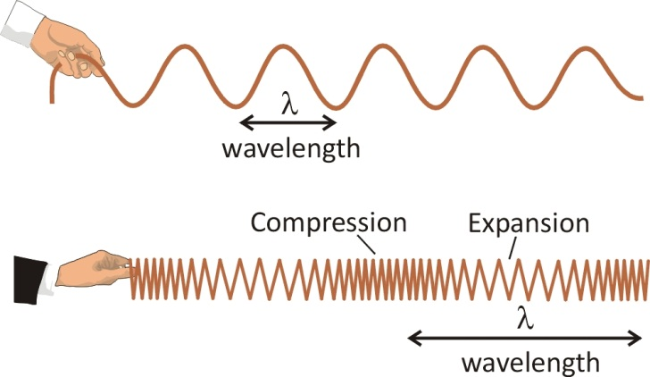

A source vibrates (vertically) and causes nearby particles to vibrate along. You see the wave that is created in the horizontal direction. So the direction of movement of the vibration is (in the same direction as/perpendicular to) the direction of travel of the wave. This is called a **transverse** wave.

1. parallel to the displacement of the vibration

**

This time the direction of movement of the vibration is (in the same direction as/perpendicular to) the direction of travel of the wave. This is called a **longitudinal** wave. It has areas of expansion and compression.

Are sound waves transverse or longitudinal?

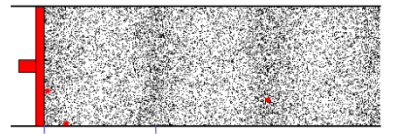

Figure 18:   
A sound wave is produced in the air by particles more or less being pressed together.   
This pressure wave propagates longitudinally.  
(Source: Educational Materials of The Institute of Sound and Vibration Research, Southampton, UK)

#### Now it’s not so easy to figure out if light, that apparently doesn’t need a medium to propagate, is a transverse or longitudinal wave. So let’s examine whether light has the known properties of waves. If so, this will support our hypothesis that light is a traveling vibration, in other words, a wave.

### Do the particles travel along with the wave?

Can you tell if the vibrating particles move along in the direction the wave is moving?

Check this out in the animations of longitudinal and transverse wave on the isvr website <http://resource.isvr.soton.ac.uk/spcg/tutorial/tutorial/Tutorial_files/Web-basics-nature.htm>

The particles go back and forth locally, but they have no net movement. A wave is a kind of disturbance that propagates. It’s the energy of the displacement that is continually transported and moves.

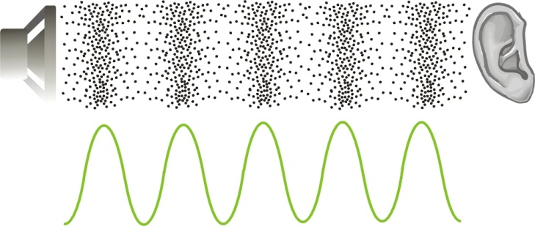

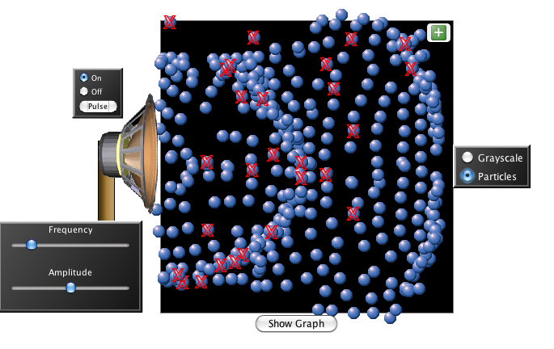For instance in a sound wave, the particles vibrate around their equilibrium position. It is the disturbance that travels: the energy of the vibration is passed on by the air particles and causes finally your eardrums to vibrate. This is illustrated by this Phet-animation. <http://phet.colorado.edu/en/simulation/wave-interference>

### The source of light waves

#### So sound originates from a vibration. And when that vibration travels through the air, you get a sound wave.

If light is a wave, we can assume *that it also originates as some kind of* ***vibration***. But which kind? It’s not that easy to visualize that. But the Dutch physicist Christiaan Huygens realized that – if light is indeed a wave phenomenon – it must also originate from a vibration.

Huygens proposed that light – because it most commonly comes from hot objects (a candle, hot glowing metal, smoldering wood…) originates from the **severe vibrating of the particles** in the hot material.   
He supposed the vibration frequency of light would be much higher than that of sound.

|  |  |
| --- | --- |
|  | http://t0.gstatic.com/images?q=tbn:ANd9GcTq8q2_tNASGPG9THkcmz3w-cVRYQsiUAHc786fQsctEtMmEX4u |
| *A hot object, like the sun or hot metal, shines light.* ***Could the vibrations of particles in the material be the source of the light waves?*** | |

## Intermezzo Sound: Are there vibrations that *don’t* repeat?

Like true scientists, let’s describe the concept of vibration frequency. Does every vibration have a frequency? Are there vibrations that don’t have a frequency?

#### Sounds with pitch and without

When you play a musical instrument like a piano or violin, you make a sound that has pitch. When you hit the table, you make a sound that has no pitch.

There is something with the vibrating string or vibrating air (in a wind instrument) that creates a sound with pitch, a tone. Hitting the table or clapping your hands on the other hand, results in a sound that has no pitch. In fact what causes this vibration to create noise (sound with no pitch).

#### What’s so special about vibrations that cause a tone compared to those that don’t?

Let’s examine this difference between tone and noise in a small experiment. You will need:

1. A microphone
2. A computer on which you can install a freeware program such as Visual Analyser (VA) that can register sound vibrations through a microphone.

**Preparation**

1. Go to [www.sillanumsoft.org](http://www.sillanumsoft.org) and download the program Visual Analyser.
2. 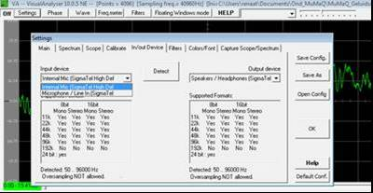Install the program on your PC and start it up.
3. Plug a microphone into the provided input on your PC
4. Hit the ‘ON’ button in the top left of your VA-window.
5. Hit ‘Settings’ (upper left in your VA)
6. Check under Settings -> In/Out Device if your microphone has been selected as input.

**Research**

Is there a difference in a vibration that has a pitch versus a vibration that makes a simple sound?

1. 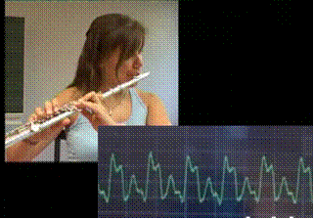Make a sound that has a pitch and one that doesn’t (for example, whistle to get a pitch and clap your hands to get a sound without a clear pitch)
2. Look at the ***vibration in time,*** *the waveform*in the upper display window of VA.
3. Repeat this for different different sounds. Grab a flute or any other musical instrument if needed. Make also some other noises.

Figure 18: A vibration in time produced by a flute. The vibration repeats itself.

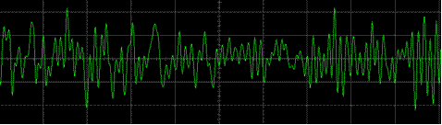

Figure 19: The vibration in time of a sound made by clapping hands. The vibration does not repeat itself.

#### What is the biggest difference between the waveform of a note and that of a sound?

A sound with a pitch repeats itself in time, we call it a *tone*. While a sound that has no pitch, is called *noise* because the waveform doesn’t repeat itself in time.

#### Period and frequency revisited for sound

If the vibration has a **repeating pattern in time** - in other words - if the vibration is **periodic**, it becomes useful to indicate the time in which the vibration repeats itself. This time is called the ***period*** of the vibration, written as ***T****.*

*For example, the period or time that passes between repeats of a vibration can be 1 second.*

If we know the period, we know how long it takes for a pattern of the vibration to return but we can also find out how many vibrations there are each second. The **number of vibrations per second** is – as we know - called the **frequency** The unit for frequency is **hertz** (Hz).

So the frequency of a periodic vibration is ratio:



A high tone has a high frequency; a low tone a low frequency.

If the period of a vibration is 0,5 s, what is the number of vibrations per second or the frequency? Hz

For example, if a tone has a frequency of 3Hz, there will be 3 complete vibrations per second. But one vibration will last …..s.   
If a note has a period of 1/10 s, then there are ……vibrations per second.

We already figured out that **period and frequency are each other’s** **inverse** which can be mathematically expressed as:

 ()

#### What is the frequency of a vibration that has a period of 1/100 s?

#### What is the vibration frequency of a la (Look it up)?

#### What is the vibration frequency of visible light? (Look it up)

#### Was Huygens correct in assuming that light has a very high frequency of vibration? (Yes/No)

How many times greater is the frequency of visible light compared to that of a la?

#### Wavelength revisited

If a vibration that repeats itself in time and can travel through the air or space, it creates a **traveling wave with a repeating shape**.

The wave pattern repeats itself after a certain length of space This length is the wavelength.

Indicate the wavelength on the nearby waveform produced by a clarinet.

The unit of wavelength is meter. The notation for wavelength is the Greek letter λ (lambda). As you know a wavelength is the distance a wave travels in one period.

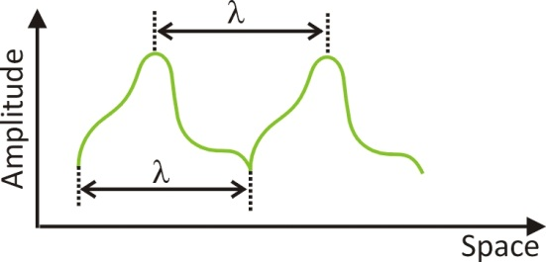

If the vibration is a simple up and down motion (what physicists call harmonic motion), the resulting wave is a sine wave. The resulting wave can also have a more compound shape (like in the figure above). As long as the vibration repeats periodically in time, the waveform will also repeat in space and you will be able to determine a wavelength.

## Light: what’s shaking?

Because light does **not** **need a material medium** to propagate, it can’t be a mechanical wave like sound or a wave on a rope (that need a material medium).

Which physical quantities do we know that are not bound to matter? Candidates therefor are *fields*. Light could arise from a change in field strength; a field vibration able to propagate through empty space. Do we know of such (force)fields that don’t need a medium, and that can indeed travel through empty space? Let us examine this.

### Force(fields) that can travel through empty space

#### The magnetic field

Remember your childhood days, and how fascinating it was to play with magnets. When you hold two magnets a certain distance apart, you can feel the **force** they exert on each other. 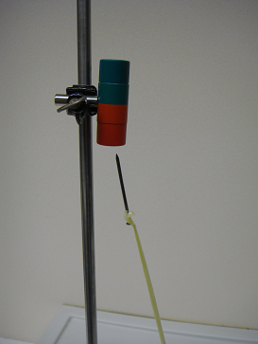  
Do the magnets need to be in **contact** in order to transfer the force??

Will magnets also exert a force on each other if they are in a **vacuum**? *Yes/No*

The magnetic force doesn’t need to be transferred through a medium. The magnet induces a magnetic field. The area around the magnet will get a new physical property, the magnetic *field*.

If a nail or such is placed in spot where the field is present, a force will transpire. This force doesn’t need a medium, it is induced by the field itself and the force can be exerted **from a distance without contact**.

#### The electric field

You’ve almost certainly seen how you can attract your hair to a (nylon) comb without making contact. Here we’re dealing with an electric force and it is . There is also a force that works from a distance *through a field*. Your hair doesn’t need to make contact with the comb.

Between the hairs, there is an electric repulsive force that also works without making contact!

There is an **electric field** around the comb and between the hairs. And wherever there is an electric field, an electric force can occur that works *from a distance without making contact*.

#### Other fields: gravitation

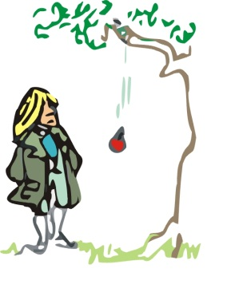Besides the electric and magnetic field, there is maybe the most obvious field of all: the gravitational field.   
To what force is it the cause?

………………………………………………………………

In 1687, Newton already determined there was a universal gravitational force between masses like the sun and the Earth for example.

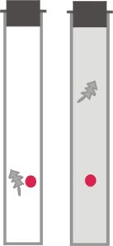Is this also an example of a force that is the result of a field? Yes / No

Does this force work in a vacuum or does it need a medium?

…………………………………………………………………

Do objects still fall in a vacuum?

*……………………………………………………………………………………………………*

Name 3 forces that are the result of a field, and that also work in a vacuum:

1. ………………………………………
2. ………………………………………
3. ………………………………………

#### Field a fundamental concept!

Initially physicists struggled a lot with the idea of “actio in distans”, a force working from a distance through ‘nothing’. But they fundamentally embedded this idea in the concept of a “field”. Since then the concept of field never left physics again and fields are ever since at the center of every physical theory: gravitation fields, electric and magnetic fields and even quantum fields!

Fields can have sources. For example masses are sources of gravitational fields, charges are sources of electric fields and magnets or electrical currents are sources of magnetic fields.

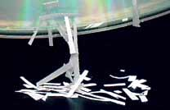

An electric field arises around a CD that is electrically charged by rubbing. The charges present in the atoms of the paper clippings are attracted by this field. (Source photo: Wikipedia)

Around the source you get an area where the field is present.

The presence of a field can be tested by placing a ‘test’-object in the field: for instance a test charge will experience an electric force in the electric field.  
The test-object will experience a force from a distance due to the field. The force may decrease with distance, but basically you’ll find the force in all points in the area around the source. This is exactly why physicists see the area around the source as a *field*.

The **force** is the **result** of the presence of a **field**.

**Example: the electric field**

If the source of the field is stationary, the field is static. Hereby is an example, a representation of the repulsive field around a positive charge. Physicists draw imaginary field lines which indicate the presence of a field.

If you would place a second positive charge in the field, a repulsive force would arise in the direction of the field lines.

**Example: the gravitational field**

If you place a mass in this gravitational field, it will experience a gravitational pull towards the center of the Earth.

Maybe you think that we have strayed far from our initial subject: the true nature of light. But physics is always a bit surprising: it connects things that doesn’t seem related at first sight. We are actually right on track for discovering the true nature of light!

*Indeed light is a field, not a gravitational field, but an electric and magnetic field.*

### Fields that change in time: waves of a field

Until now, the fields we’ve described don’t vary in time: they are static fields. But is it thinkable that the strength of a field changes in time? How this can be done? Maybe we have to make the source of the field move?

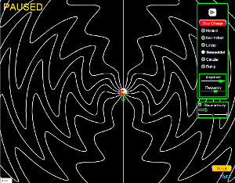Find out how you can vary a static electric field in time with the following Phet-applet.

<http://phet.colorado.edu/en/simulation/radiating-charge>

How can you produce a magnetic field that varies in time?

Let’s examine this further with some simple materials:

The field of a *vibrating magnet* will spread in space and vary in time. You can see the effects of the vibrating field when you vibrate a magnet over aluminum shavings or filings.

Describe what happens. Does the vibrating magnet make contact with the clippings?



Can you think of an experiment to make an electric field that varies in time in order to observe the effects of a ‘waving field’?

…………………………………………………………… ……………………………………………………………

If you move a (negatively) charged comb, back and forth, you can make a piece of paper wobble from a distance!

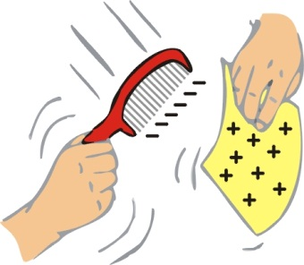 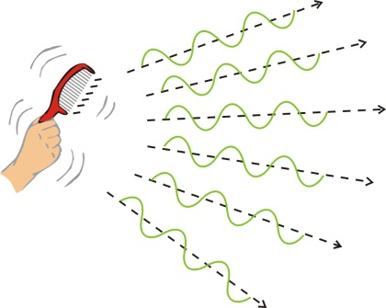

This too can be clarified by assuming the field induced by the charged comb can vary in time, just like a moving wave. It explains the observed movements of the piece of paper.

An oscillating field is perfectly conceivable:   
the wave of the field can propagate in vacuum,   
because the field itself could already exist in a vacuum.

Newton assumed that variations in the field were instantaneous. Since Einstein's theory of relativity, we know that the propagation of a field occurs at the **speed of light** at the most. The information that a star or a charged particle has changed position is “communicated” through the field, through the changes of the field (and this at light speed!)

Information about a change in a field   
can be transported from one place to another   
by means of **a wave in that field**.

This form of **energy transfer**, **through a field**, is utilized daily when you use Wi-Fi, call on you cell phone or turn on your radio.

### Electromagnetic waves

The oscillating field that arose when you moved the electrically charged comb up and down was from electromagnetic nature: it caused an electromagnetic wave. Why do we say *electromagnetic* and not just electric wave?

Until now, we’ve talked about electric and magnetic fields as if they were two separate things. In the early 19th century, the Scottish physicists James **Maxwell** discovered that *electric and magnetic fields that vary in time actually induce each other* and thus cause each other’s propagation:

An electric field that changes in time   
produces a magnetic field   
and vice versa   
(a magnetic field that changes in time, produces an electric field)

Therefore *waves from an* *electric field can’t exist without magnetic waves occurring too* and vice versa. In the next section, you can check experimentally that changes in electric and magnetic fields induce one another.

Physics has also shown that the two fields of an electromagnetic wave (the electric field and the magnetic field) are perpendicular to each other (see figure)

It turns out that light itself is a propagating electromagnetic wave*.*

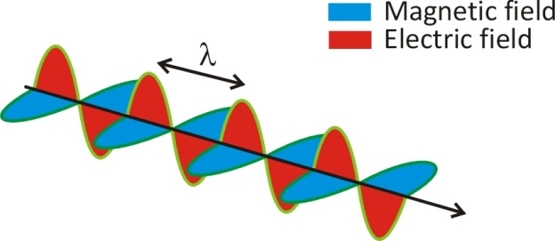

Figure 20:   
An electromagnetic wave is comprised of   
an **oscillating** **electric** field and perpendicular to it,   
an **oscillating** **magnetic** field, with the same periodicity.   
Source: photonicswiki

Also look at following animation:

<http://www.molphys.leidenuniv.nl/monos/smo/index.html?basics/light_anim.htm>

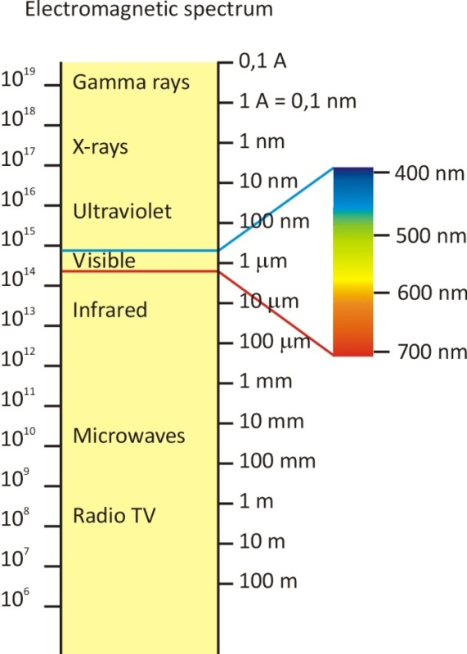The radio waves that carry the music to your radio, the microwaves in your microwave oven, the waves that are used by your cell phone and Wi-Fi networks, these are all electromagnetic waves.

All these waves are physically the same. So then **what is the difference between light, radio waves, microwave**... etc.?

……………………………………………..

Check out the figure, it shows a diagram of all the electromagnetic waves.

Arrange the following wave in ascending order:   
Visible light, radio waves, UV, gamma-rays, microwaves

*……………………………………………… ………………………………………………*

## A sea of electromagnetic waves

We are actually living in a “sea” of electromagnetic waves, most of which we can’t even see of feel. Our detector, the eye, is only sensitive to a specific interval of wavelengths. These electromagnetic waves are therefor called visible light.

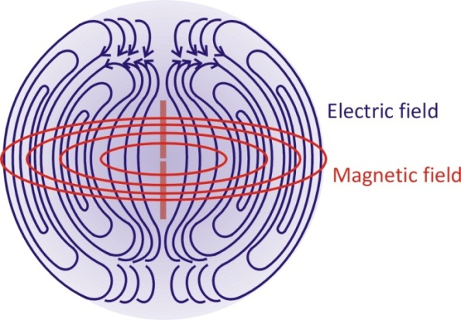Electromagnetic waves can be induced by **shaking** an electrically charged comb for example, but also by an **antenna** where the **charges move back and forth** in a piece of metal wire. 50Hz radio waves are very typical because we are continually surrounded by a 50Hz alternating current.

The following figure shows a sketch of an antenna and how the electric (blue) and the magnetic (red) fields due to an alternating current spread out in 3 dimensions

Finally we know what’s shaking with light waves...

What oscillates with light?

Why can light propagate in a vacuum?