

Bridge between research in modern physics  
and entrepreneurship in nanotechnology

Quantum Physics

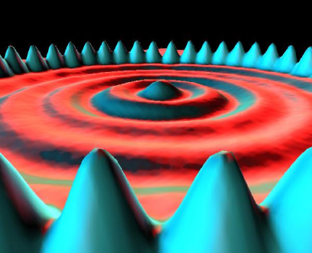The physics of the very small   
with great applications

http://i.creativecommons.org/l/by-nc-sa/3.0/88x31.png

Quantum Spin-Off is funded by the European Union under the LLP Comenius programme   
(540059-LLP-1-2013-1-BE-COMENIUS-CMP).  
Renaat Frans, Hans Bekaert, Laura Tamassia   
Contact: [renaat.frans@khlim.be](mailto:renaat.frans@khlim.be)

**Table of Contents**

**Part 1: Why Quantum Physics?**

LEARNING STATION I: INEXPLICABLE PHENOMENA? 4

1 The idea of trajectory in classical mechanics 4

2 Loss of the concept of trajectory: the double slit experiment 5

2.a Through which slit will the electron go? 5

2.b Double slit experiment for waves 7

2.c Double slit experiment for electrons: particle-wave duality 7

2.d Double slit experiment for large molecules 8

3 Emission and absorption spectra of chemical substances 8

3.a Typical colours of a chemical element 8

3.b Atomic discrete emission lines 9

3.c Discrete absorption lines 11

4 Explaining discrete spectral lines? 12

LEARNING STATION II: WHAT IS LIGHT? 15

1 Is light made up of a ray of particles? 15

1.a Newton’s particle theory of light 15

1.b Foucault’s experiment compared the speed of light in air to that in water 18

2 Is light made up of waves? 19

2.a The assumptions of Christiaan Huygens 19

2.b How are light rays able to cross each other? 19

2.c Which type of displacement occurs when separate waves come together? 20

2.d Wave front, wavelength, period 21

2.e Speed of a wave 22

3 How Huygens explained the properties of light 22

3.a The Huygens principle 22

3.b Explaining reflection and refraction using wave theory 23

3.c Explaining diffraction using wave theory 24

4 The 2-slit experiment for light 25

4.a Why do minima and maxima occur in the 2-slit experiment? 25

4.b Different distance, different phase 26

LEARNING STATION III: WHAT OSCILLATES WITH LIGHT? 27

1 Mechanical waves 27

1.a Source of mechanical waves 27

1.b Medium needed? 27

1.c Propagation and displacement in the same direction or in a different direction? 28

1.d Do the particles travel along with the wave? 29

1.e The source of light waves 30

2 Intermezzo Sound: Are there vibrations that don’t repeat? 30

3 Light: what’s shaking? 33

3.a Force(fields) that can travel through empty space 33

3.b Fields that change in time: waves of a field 35

3.c Electromagnetic waves 36

LEARNING STATION IV: WAVE PARTICLE DUALITY 39

1 Double slit experiment with light of low intensity 39

2 Quantum Theory of light and matter 41

2.a Electromagnetic waves and their energy quanta: photons. 41

2.b Matter waves and quanta 42

3 Quantum Fields 43

LEARNING STATION V:   
PREDICTING THE HYDROGEN EMISSION LINES WITH A QUANTUM MODEL 45

1 Predicting the emission spectra of elements? 45

1.a Emission lines of elements: classically not understood 45

1.b Quantum Fields of matter and light 45

2 The enigmatic formula of Balmer 46

2.a Again the integer numbers of Pythagoras in nature 46

2.b The Balmer formula and the hydrogen spectrum 47

3 Waves and integer numbers: standing waves 48

3.a Integer numbers and natural harmonics 48

3.b Integer numbers in the wavelengths of standing waves 49

3.c Integer multiples in the frequencies of natural tones (Eigen frequencies) 51

4 Standing electron waves in the hydrogen atom 52

4.a Fitting the waves 52

4.b Wave and Particle Duality 54

4.c Predicting the size of the hydrogen atom 55

5 Predicting the hydrogen emission lines with a quantum atomic model 56

5.a Quantised energies 56

5.b Quantised energy transitions 57

6 Interpretation of the Balmer formula 59

http://i.creativecommons.org/l/by-nc-sa/3.0/88x31.png**Attribution-NonCommercial-ShareAlike 4.0 International** (CC BY-NC-SA 4.0)

Under the following terms:

* Attribution — You must give [appropriate credit](https://creativecommons.org/licenses/by-nc-sa/4.0/), provide a link to the license, and [indicate if changes were made](https://creativecommons.org/licenses/by-nc-sa/4.0/). You may do so in any reasonable manner, but not in any way that suggests the licensor endorses you or your use.
* NonCommercial — You may not use the material for [commercial purposes](https://creativecommons.org/licenses/by-nc-sa/4.0/).

You can:

* Share — copy and redistribute the material in any medium or format
* Adapt — remix, transform, and build upon the material

The licensor cannot revoke these freedoms as long as you follow the license terms.

You have to refer to this work as follows:

Frans R., Tamassia L. (2014) Quantum SpinOff Learning Stations. Centre for Subject Matter Teaching, KHLim Katholieke Hogeschool Limburg, Diepenbeek, Belgium



**Quantum Spin Off**

*The physics of the very small with great applications*

Part 1  
Why Quantum Physics?

Who ordered this?

http://i.creativecommons.org/l/by-nc-sa/3.0/88x31.png

# Learning station I: Inexplicable phenomena?

## The idea of trajectory in classical mechanics

In classical mechanics, if you know the initial position, the initial velocity and the forces acting upon a mass, you can predict its trajectory.

Predicting the trajectory given initial conditions and forces, follows from Newton’s mechanics formulated in 1687 in his ‘Principia Mathematica Philosophae Naturalis”.

Newton based his mechanics on three principles (nowadays called Newton laws).

Write down these three principles (look them up if you need to):



**Example: Predicting the trajectory of an horizontally launched projectile**

Consider an object launched horizontally with initial velocity v0 from a certain height h

(in ideal circumstances, with no air resistance). What is its trajectory? Can you predict it exactly by using classical mechanics?

To calculate the trajectory, you must first write the x- and y-coordinates in function of time: x(t) and y(t).

Because of Newton’s 1st principle (also called ………….……………………………………………..) the velocity in the x-direction, vx (changes/remains constant). As a result, the

x-coordinate increases, it is directly proportional to time

$$x=v_{0}.t$$

Gravity works in the y-direction only and causes a uniformly (accelerated/decelerated/ constant) motion. The distance fallen increases quadratically with time. From kinematics you know that

$$distance fallen=\frac{1}{2}gt^{2}$$

where g is the acceleration due to gravity. If you start at height h, your y-coordinate becomes

$$y\left(t\right)=h-\frac{1}{2}{gt}^{2}$$

Since you can calculate x(t) and y(t), you can also figure out the trajectory of the object in space: y(x).

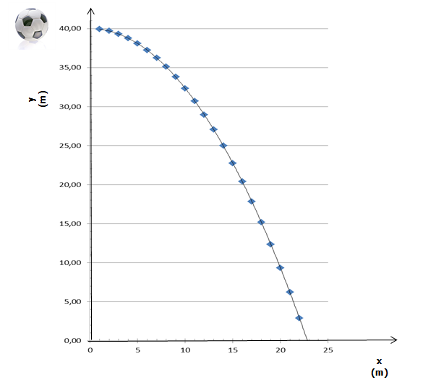You can eliminate t and write an expression for y as a function of x. In this way you get the expression y(x) for the trajectory, plotted in the picture:

……………………………………

Figure 1 The trajectory of a ball, launched horizontally from a height of 40m with an initial velocity v0 of 8 m/s, in the absence of air resistance

.

*Classical mechanics:*

*Given the initial position, the initial speed and the forces acting on a mass*

*↓  
You can predict the trajectory of the mass*

## Loss of the concept of trajectory: the double slit experiment

### Through which slit will the electron go?

It is possible to extract *single electrons from matter* and to shoot them on a target like tiny bullets.

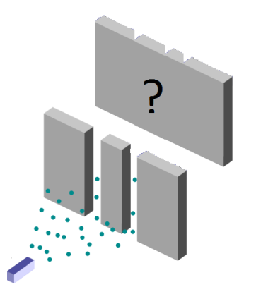When you shoot electrons on a target with 2 thin slits close to each other, you are actually conducting the famous double slit experiment for electrons. If you take into account Newton’s classical mechanics, which considers electrons as tiny balls or bullets, what pattern would you expect to see on a screen behind the slits?

Figure 2 Schematic representation of the double slit experiment with electrons   
(Source: Adapted from Wikipedia Public Domain)

.

For instance, you can see classical electrons as the tiny ink droplets coming out of a spray can. If you spray the paint on a sheet with two slits and hold a screen behind it, what pattern would you observe on the screen? Make a drawing of the experiment, and make sure the expected pattern on the screen is clearly visible.

*The classical expectation for the pattern of the double slit experiment for electrons*

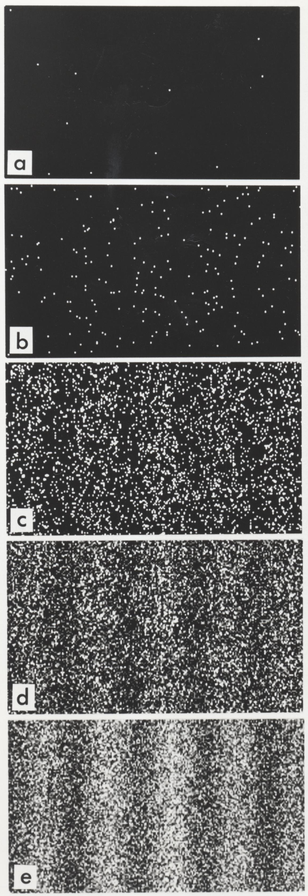The researchers of Hitachi Labs have succeeded in conducting the double slit experiment with electrons by shooting their electrons one at a time and by recording where they arrive on the screen. How the resulting pattern builds up on the screen is shown by the series of picture in the figure and in the video below: [www.youtube.com/watch?v=oxknfn97vFE](http://www.youtube.com/watch?v=oxknfn97vFE)

Look at the specific pattern electrons produce on the screen: it’s clear that in certain spots more electrons arrive than in others. Compare the final pattern the researchers have obtained with your prediction based on classical mechanics: is the pattern the same?

(Yes/No)

After having seen the results of the real experiment, can you still claim that a single electron passes through one slit or the other?

(Yes/No)

Can you still talk about the trajectory of an electron if you can’t assume that the electron has passed through one slit or the other?

(Yes/No)

The concepts of exact trajectory and position seem to disappear. Classical mechanics falls short. Watch also the animation of dr. Quantum[1]: [www.youtube.com/watch?v=DfPeprQ7oGc](http://www.youtube.com/watch?v=DfPeprQ7oGc)

Figure 3 Build-​​up of the pat­tern on the screen for the double slit experiment for electrons. The number of detected elec­trons is 100 (b), 3000 (c), 20000 (d), 70000 (e). (Bron: Tono­mura, A., Endo, J., Mat­suda, T., and Kawasaki, T. (1989) Demon­stra­tion of single-​​electron buildup of an inter­fer­ence pat­tern, Amer­ican Journal of Physics 57 (2), 117–120)

.

Electrons arrive one by one on the screen, but you can’t tell through which slit they have passed. Are electrons no longer particles then?

### Double slit experiment for waves

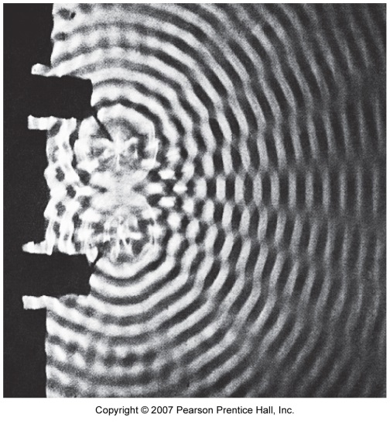

Let’s look at the double slit experiment for water waves in classical mechanics (see picture). Crests appear clear, troughs appear dark, flat areas appear grey.   
Where do you see crests and troughs? Write down the corresponding number of the area(s):…………….  
Where do you see flat areas? …………………….

.

Figure 4 *Interference of water waves (Bron: PSSC Physics Haber-Schaim, Dodge, Gardner, Shore. Kendall/Hunt, 1991.)*

The pattern that would be produced on the equivalent of a screen placed on the right edge of the picture, displays the same structure of the pattern resulting from the real double slit experiment with electrons. What you see here and there is an interference pattern of waves.

In quantum mechanics particles also display wave features. You will examine what this exactly means in the next learning stations.

### Double slit experiment for electrons: particle-wave duality

In quantum mechanics, an electron can’t be viewed as merely a “ball”, like in classical physics.

An electron displays also wave features:

Electrons arrive one at a time, but the pattern formed by these particles is an interference pattern,   
due to the wave features of electrons!

This weird particle-wave duality has been proven to be a fundamental aspect of nature.

Quantum mechanics has changed our way of thinking about the world. In the following learning stations, you will investigate whether this dual nature also applies to light.

*In 2002 the readers of the scientific journal Physics World voted for the most beautiful physics experiment. Check out which experiment won!*

### Double slit experiment for large molecules

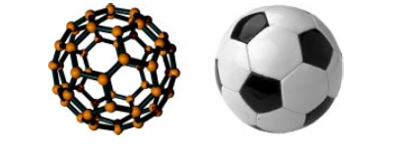Electrons are extremely small particles and you might think that the particle-wave duality only applies to them.

Do you think the behaviour of an electron is exceptional, or will larger molecules also produce a similar interference pattern in the double slit experiment?

Figure 5 The fullerene C60 molecule is the smallest soccer ball in the world (from: O. Nairz, M. Arndt and A. Zeilinger, "Quantum interference experiments with large molecules")

.

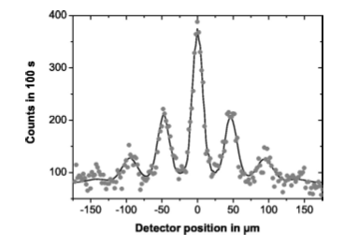The double slit experiment has also been performed with **fullerene** **molecules**, C60, also called **bucky** **balls**. These molecules are made from 60 carbon atoms bound together in a shape similar to a soccer ball. A molecular soccer ball if you will, the fullerene molecule is the smallest soccer ball in the world. The result of the experiment is shown in figure 6.

Figure 6 Fullerene interference pattern (uit: O. Nairz, M. Arndt en A. Zeilinger, "Quantum interference experiments with large molecules")

Is the electron “special” or is particle-wave duality a fundamental characteristic of all matter?

## Emission and absorption spectra of chemical substances

### Typical colours of a chemical element

At the end of the 19th century it was already well known that chemical substances send out characteristic colours when heated. If you hold a sample of the chemical substance in a flame, you will see a colour that is typical of that substance.

Figure 7 Sodium (Na) held in a flame gives a characteristic yellow colour. If one does the same with copper (Cu), one gets a typical blue colour.

This effect can be used to recognize a chemical substance!

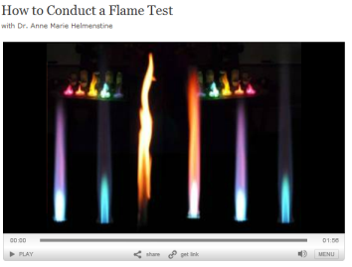**Conduct yourself some flame tests**.

#### The video “How to conduct a flame test” explains how to do the experiment: [video.about.com/chemistry/How-to-Do-a-Flame-Test.htm](http://video.about.com/chemistry/How-to-Do-a-Flame-Test.htm) If needed, you can also ask your chemistry teacher for advice. Conduct the flame tests. How is it possible that each chemical substance sends out its own characteristic colour? Write down the chemical substance you have used and the corresponding flame colour in the table below.

|  |  |
| --- | --- |
| Chemical substance | Flame colour |
|  |  |
|  |  |
|  |  |
|  |  |

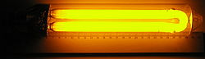The typical colours sent out by chemical substances can be seen even better in a **gas discharge lamp**. These lamps are transparent tubes filled in with a specific gas. When you apply an electrical tension to the extremes of the lamp tube, the lamp lights up with the typical colour of the gas present in the tube.

*Sodium lamps* are often present along motorways and give, indeed, the typical yellow colour of sodium.   
*Mercury lamps* can be seen for instance as car head lamps and give a typical white-blue light.

### Atomic discrete emission lines

When you heat up a chemical substance in a flame or when you light up the gas of a chemical element in a gas discharge lamp, you observe the characteristic colour of the substance you have used. Sodium in a flame or in a gas discharge lamp always gives an identical yellow colour. When a substance is heated up in a flame or put under tension in a gas discharge lamp, the molecules split up and as a result the substance is present in its **atomic state**.

But then it must be the atoms themselves that send out the characteristic colours!

The question that physicists at the end the 19th century and in the beginning of the 20th century wanted to answer was:

How can an atom send out such precise colours?

Physicists of that time had for sure not expected that the path leading to the answer to this question would also lead to totally new physics: quantum physics! In these learning stations we will follow this path together with you. We will discover that classical physics does not hold anymore at the atomic scale and that new fundamental behaviour of matter arises. A behaviour that we, and all physicists up to the beginning of the 20th century, had totally overlooked.

Our quest starts from the characteristic colours of emission spectra. With a prism or a diffraction grating we can split light and see the colours out of which it is made. A diffraction grating is a diaphragm with very many parallel thin slits cut in it.

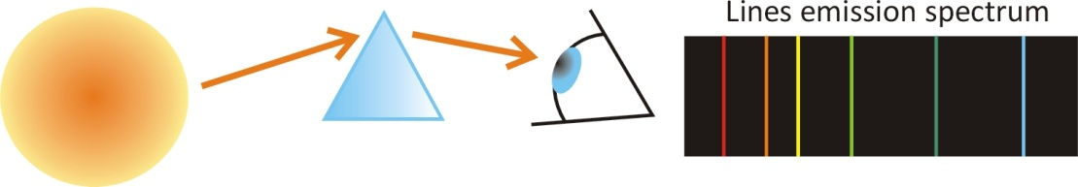

Figure 8 An atomic gas emits light that can be split in the colours that compose it with a prism or a diffraction grating. In this way one can see that the observed colour is actually made out of a **discrete** **number** of sharp colour lines. These discrete emission lines are typical of the element present in the lamp.

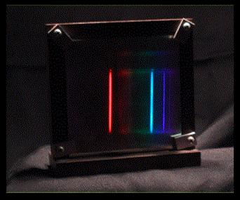LWe can for instance look at the emission spectrum of hydrogen, the first element in the table of Mendelev and the simplest and most common chemical substance in the universe. If you have a hydrogen gas discharge lamp and a spectroscope in your physics lab at school, you should go and see the emission spectrum with your own eyes. Ask your physics teacher for help!

Figure 9 The characteristic line spectrum of atomic **hydrogen** is composed out of 3 sharp lines: a red, a blue and a violet line.

In the last learning station of part 1, you will, exactly as the great fathers of quantum physics Niels Bohr and Louis De Broglie, be able to *predict the* *wavelength of the emission lines*, and with a precision of 4 digits after the comma!

#### Determine the elements present in 4 different gas discharge lamps

In the following video the light produced by four gas discharge lamps filled in with different elements is split in the composing colours by using a diffraction grating.

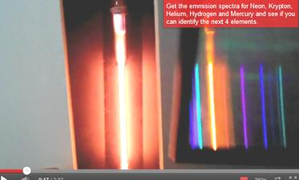Look up the emission spectra of Neon, Krypton, Helium, Hydrogen and Mercury. Compare these emission spectra to the spectra of the different lamps. Determine then which chemical substance is present in each lamp.

Figure 10 Atomic Spectra - Name that element [www.youtube.com/watch?v=1gT7hlYvKg0&feature=related](http://www.youtube.com/watch?v=1gT7hlYvKg0&feature=related)

|  |  |
| --- | --- |
| Lamp | Which element is inside? |
| 1 |  |
| 2 |  |
| 3 |  |
| 4 |  |

#### Analyse the light sent out by stars

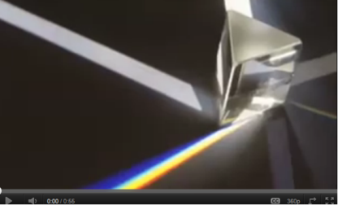In measurements of the spectrum of the sun or of other **stars**, one can recognize the characteristic lines of mainly H and He. From this we learn that those stars are mainly made out of hydrogen and helium. A further analysis of these spectra also gives us information on the age of stars and even on how they move.

Watch the video ‘The Spectrum of Stars’ at [www.youtube.com/watch?v=l4yg4HTm3uk](http://www.youtube.com/watch?v=l4yg4HTm3uk)

Atoms send out precise discrete emission lines, which allow us to see the signature of chemical elements in stars at a distance of light-years from us. But the opposite is also possible: light can be absorbed by clouds of atomic gases. These atomic clouds absorb only specific discrete colour lines out of the light passing through them.

### Discrete absorption lines

When the light from a star passes through a cold gas cloud on its way to the observer, specific colours can be absorbed by the cloud, resulting in a series of black absorbed lines in the spectrum of the star as seen by the observer. These lines are called absorption lines and the associated spectrum is called an absorption spectrum.

The analysis of the absorption spectrum reveals which chemical elements are present in the gas cloud.

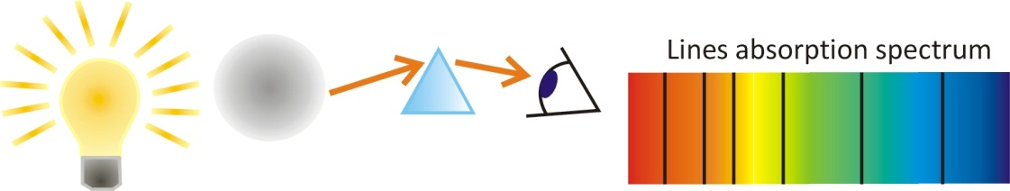

Figure 11 When ‘white’ light goes through an atomic gas, specific colour lines are ‘blocked’ by the gas and never arrive at the observer. The atoms in the gas have absorbed these colours that disappear from the light emerging from the gas, resulting in a **discrete** absorption spectrum seen by the observer.

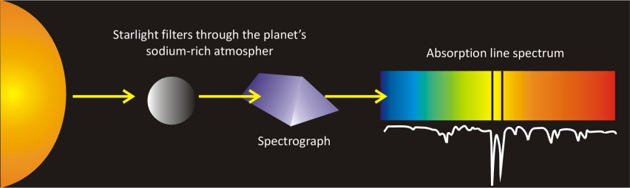For instance, one can determine the chemical elements in the atmosphere of a planet by measuring the absorption spectrum of sunlight that has gone through the atmosphere of that planet.

The absorption of light for specific colour lines takes place when light has been absorbed by a specific element:

Emission and absorption spectra are   
the signature of the presence of specific atoms or molecules.

## Explaining discrete spectral lines?

We are now back to our question:

How can an atom send out and absorb such specific colours?

The answer to this question must be sought, first of all, in the atom itself.

How can an atom send out light?

How can an atom absorb light?

Although classical physicists in the beginning didn’t agree on what light really is, it became later clear that light should be an electromagnetic phenomenon and that the emission of light should very likely have something to do with the *movement of charges in the atom*. Since an *electron* is a charged particle, it could with its *movement* create an *electromagnetic field*, and thus *light*.

Can classical physics explain  
why an atom can emit or absorb discrete line spectra?

To understand how light, a traveling oscillating electromagnetic field, can arise, we must look at the movement of the electric charges in the atom. Electrons are moving charges in the atom. They can be seen as atomic ‘senders’ that, due to their movement, emit an oscillating electromagnetic wave: light. They behave just like an antenna that, as a result of the alternating electrical current inside, emits radio or infrared waves, according to the frequency of the oscillating current. The emitted radio or infrared waves are in fact also a form of ‘light’, but with a longer wavelength than visible light.

Therefore, classical physics can explain the general phenomenon of the emission of light by atoms as a consequence of the movement of electrons in the atom. But can the movement of electrons be so perfectly organized that only specific discrete colour lines will be emitted? To investigate this, we have to inspect the classical atomic model of Rutherford closely. The atomic model of Rutherford was the last classical atomic model before the advent of quantum mechanics.

#### Sketch the classical ‘planetary’ atomic model of Rutherford:

#### Look up in which period Rutherford worked in Cambridge:

Niels Bohr, a Danish scientist who had studied with Rutherford in Cambridge, realised that a classical atomic model, picturing electrons circling around the nucleus as planets, could never lead to the emission of the observed discrete colour lines. These discrete colour lines require a very specific movement of oscillation of the electron. For sending out red light (with a lower frequency) should the electron move slower, for sending out blue light (with a higher frequency) should the electron move faster. A specific circular motion of the electron would then produce a specific colour. The hydrogen atom, for instance, that has for sure 3 sharp emission lines, should then have 3 corresponding electron orbits.

Figure 12 Heisenberg and Bohr in Copenhagen in 1934

(Source: AIP, American Institute for Physics, photo taken by Paul Ehrenfest).

But in the classical atomic model of Rutherford electrons circle around the nucleus like planets around the sun. And a planet can always change to a ‘higher’ or a ‘lower’ orbit if energy is added or removed. But why should only a few orbits be allowed, those associated with the frequencies of the observed light of the emission lines? In the classical picture, all possible energies are allowed and a circling electron could emit light of all possible frequencies, and thus of all possible colours.

Even worse, a circling electron in a classical atomic model, like the one of Rutherford, keeps sending out light all the time. Exactly like an antenna with an alternating current inside sends out electromagnetic waves the whole time, also the circling electron should keep sending out electromagnetic waves.

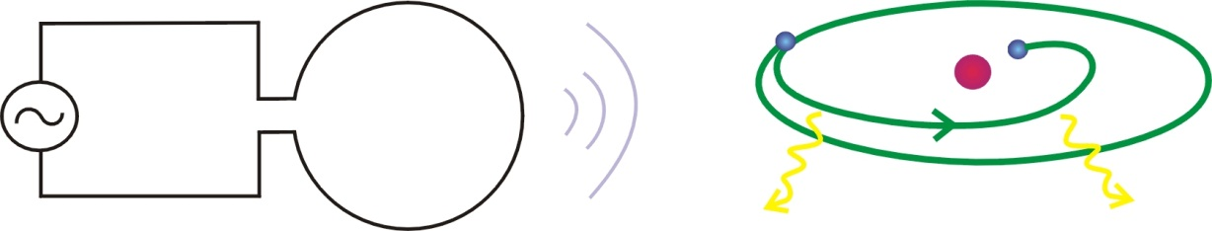

Figure 13 Just like the electrons of the alternating current in an antenna keep emitting electromagnetic waves, would an electron circling around the nucleus in an atom also keep sending out electromagnetic waves. Niels Bohr realised that such an electron should then keep losing energy and, as a result, would just fall on the nucleus. According to classical physics, stable atoms simply cannot exist. And electrons circling exactly and only with the few discrete frequencies associated to the observed emission lines, could in no way be modelled in classical physics.  
(Figure source: EDN, March 2000)

But while energy keeps being added to an antenna, nobody adds energy to the atom. The emission of electromagnetic waves by the atom can then only take place at the cost of the movement energy of the circling electrons. This means that the circling electrons would keep losing energy while emitting the electromagnetic field.

Bohr realised that electrons, as a result of this continuous energy loss due to the emission of light, would also keep losing orbit velocity, and in very short time would just fall right on the nucleus. With other words, Niels Bohr understood that a planetary atom with circling electrons, physically, could not exist at all. But we do exist, and how is this possible then?

According to classical physics,   
the ‘planetary’ atomic model of Rutherford does not make any sense

and matter cannot exist.

Classical physics cannot explain

the observed emission and absorption lines of chemical elements.

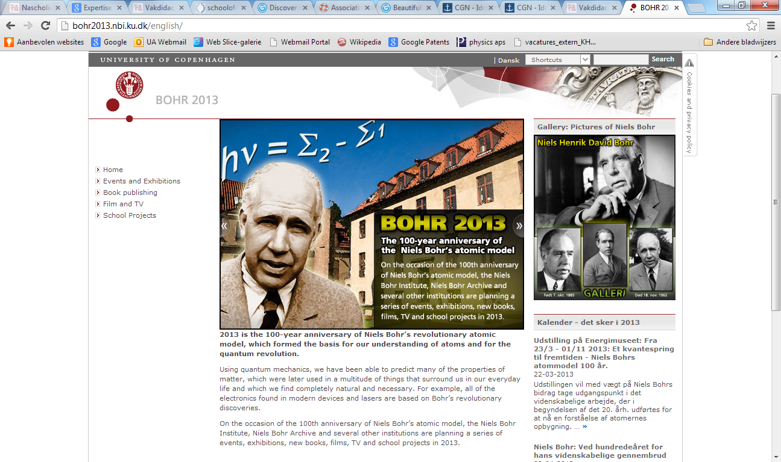

In 2013 it was exactly 100 years since Bohr proposed his first quantum atomic model. In one of the last learning stations we will compute the discrete emission lines of the hydrogen atom with the atomic model of De Broglie.

In the following we will take you with us in the quest to understand the behaviour of light and matter. Just like the great fathers of quantum physics Max Planck, Albert Einstein, Niels Bohr, Louis De Broglie and Werner Heisenberg, we will see that the behaviour of light and matter **cannot** be understood by classical mechanics and electromagnetism and a brand new theory has to be introduced: quantum mechanics.

In the following chapter we begin our search with the question: **what is light**?

1. The video of dr. Quantum shows the electron being “split” in two in front of the slits: this is not true according to quantum physics!